ATANAS KAMBITOV COMPELTED COURSES

Completed Udemy Courses:

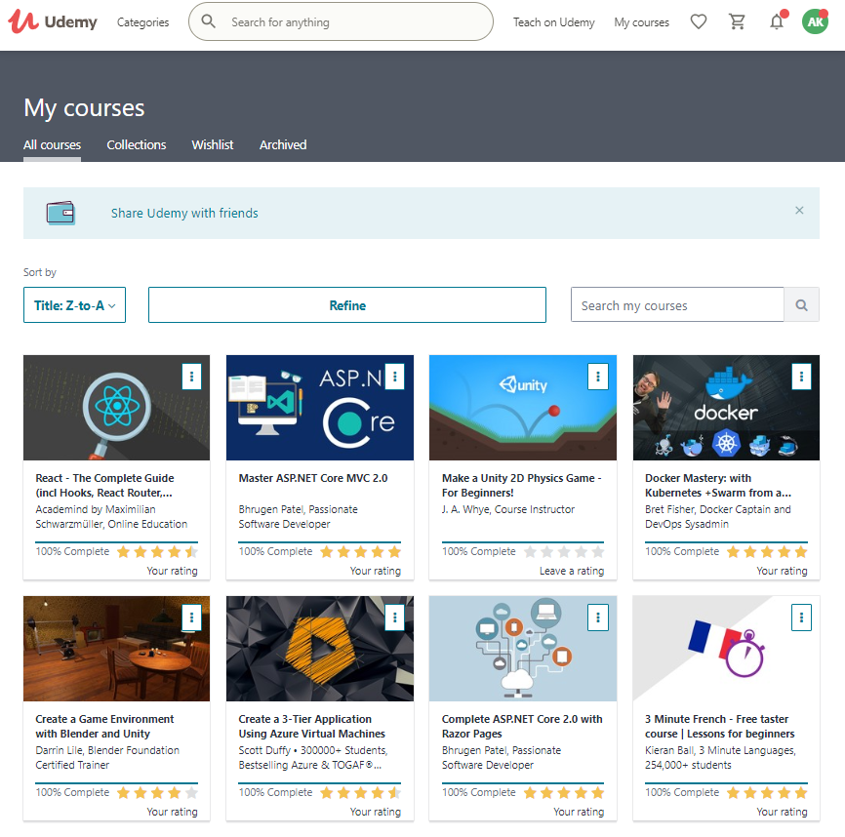

Completed Pluralsight Courses



